

**A** **PROJECT REPORT**

**ON**

“[[  **Restaurant management system**]]”

## Submitted in partial fulfillment for the Course of

**Database Management System Laboratory**

Submitted by:

|  |  |  |
| --- | --- | --- |
| **S/L** | **Name** | **ID** |
| **1** | **Shourov Roy** | **201-15-3540** |
| **2** | **Lam ya Auntipa** | **201-15-3307** |
| **3** | **Somu Saha** | **201-15-3622** |

Submitted to

|  |
| --- |
| **Rubel Sheikh**  Lecturer  Department of Computer Science and Engineering Daffodil International University |

**TABLE OF CONTENTS**

**ABSTRACT**

1. INTRODUCTION
   1. PROJECT AIMS AND OBJECTIVES
   2. BACKGROUND OF PROJECT
   3. SCOPE OF THE PROJECT
2. SYSTEM ANALYSIS
   1. SOFTWARE REQUIREMENT SPECIFICATION
   2. EXISTING VS PROPOSED
   3. SOFTWARE TOOL USED
3. SYSTEM DESIGN
   1. TABLE DESIGN
   2. E-R DIAGRAM OF THE SYSTEM
4. SYSTEM IMPLEMENTATION
   1. MODULE DESCRIPTION
   2. SCREEN SHOTS
5. SYSTEM TESTING
   1. UNIT TESTING
   2. INTEGRATION TESTING
6. CONCLUSION & FUTURE SCOPE
7. REFERENCES

CHAPTER 1

INTRODUCTION

This restaurant management system can be used by employees in a restaurant to handle the clients, their orders and can help them easily find free tables. The restaurant menu is organized by categories (appetizers, soups, salads, entrees, sides and drinks) of menu items. Each menu item has a name, price and associated recipe. A recipe for a menu item has a chef, preparation instructions and associated ingredients. Restaurant management system is the system for manage the restaurant business. Restaurant management can vary across multiple management styles, however, there is always one common denominator when it comes to setting goals: maximizing a restaurant’s profitability. In order to maximize a restaurant’s profitability, one has to always examine and understand a restaurant’s operational costs and how these relate to a restaurant’s productivity and efficiency in delivering quality service to its customers. Management takes a very important role in controlling and manipulating the balance of costs and profitability. An effective manager must always concern himself/herself with restaurant issues that pertain to inventory/stocking, pricing, order-taking, and much more. Oftentimes, a restaurant’s profitability either rises or falls depending on how well it is being managed. Managing a restaurant using a well-developed software minimizes the liabilities of mismanagement and productivity loopholes. The incorporation of a Restaurant Management Software in the managing of various business processes entails that your restaurant is competitive, innovative, well-managed, and up-to-date with the latest management and business trends.

**PROJECT AIMS**

This restaurant management system will help the employees in a restaurant to handle the clients, their orders and can help them easily find free tables.

Managing a restaurant using a well-developed software minimizes the liabilities of mismanagement and productivity loopholes. The incorporation of a Restaurant Management Software in the managing of various business processes entails that your restaurant is competitive, innovative, well-managed, and up-to-date with the latest management and business trends.

**PROJECT OBJECTIVES**

The main objective is to maximize the profit by increasing efficient and decreasing the mistakes that takes place in the kitchen, this will be done without compromising customer satisfaction. At this moment of time, there are still numerous restaurants that still use paper based system to get messages across between the restaurant and the kitchen, this way of communication is one of the least efficient method. However, this approach may be implemented and designed in a successful profitable restaurant but there are numerous problems which might be seen as reducing the restaurants efficiency, they are the following:

• The lack of communication that is caused by handwriting.

• Uncontrolled order logging (poor order taking).

• Unproductive communication between restaurant and kitchen.

• Faults with order taking and lack of time management.

• Lack of good quality stock management.

• Limited statistical output.

So, in order to overcome these problems, we have made an application that is restaurant management system that mainly focuses on the above given problems. We have tried to build a user-friendly interface.

**BACKGROUND OF THE PROJECT**

Platform Choice -

Choosing a suitable platform normally goes down to the programmers experience and the type of software to be developed. The restaurant management system could be developed as a web application or a standalone application but must also be widely supported and platform-independent. Therefore as the developer has minimal or no experience in web programming, the decision was taken to develop a standalone application.

Software Choice -

In software development, the use of integrated development environments (IDE) can increase the efficiency of a programmer. An IDE is a software application that consists of a source code editor, compiler and debugging tools with its main aim to assist the programmer. Simple

notepads are not strictly IDEs but can do the same job with the assistance of a compiler. The two most popular IDEs available for Java programming are Netbeans and Eclipse as they are free, support multiple platforms and offer many features including integrated version control and debugging tools. The two main problems with IDE’s are that due to the wealth of features available and plug-in support, there is an associated cost, as their performance is poor and in particular they require more memory and processing power than a standard text editor.

Requirement Gathering-

Requirement gathering is a very important step in software engineering. According to an article written by Craig Murphy [11], Boehm’s cost model discusses how discovering errors at an early stage of software development can reduce overall costs. Figure 2.2 is an example of Boehm’s cost model and uses the waterfall technique to give a visual insight into how important gathering accurate requirements can be.

And we are always support the user-

1. Customer satisfaction by rapid,
2. continuous delivery of useful software.
3. Working software that is delivered frequently.
4. A welcomed late change in requirements.
5. Simplicity.
6. Regular adaptation to changing circumstances.

**SCOPE OF THE PROJECT**

Scope of project in building a computerized system for silk route to handle billing restaurant records was to include the employees who are involved in the process of billing of a customer to storage of restaurant records and enables to view the records as desired. The employees are given limited access in order to safe guard the privacy and security of the records. The database is maintained in the whole project.

CHAPTER 2

SYSTEM ANALYSIS

SOFTWARE REQUIREMENT SPECIFICATION

*Here are all the discussion we have done-

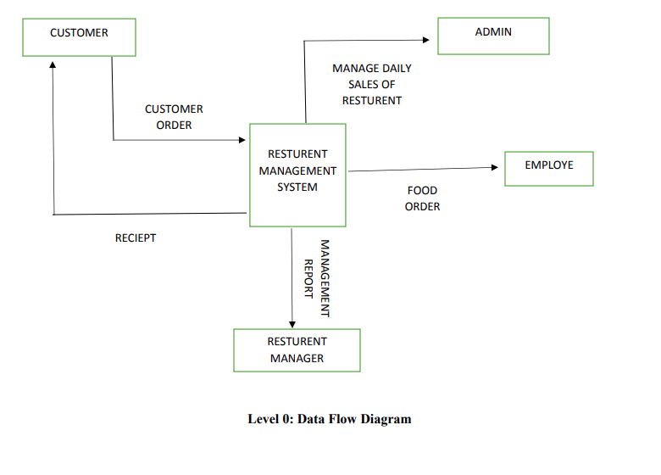

:Data flow diagram-1

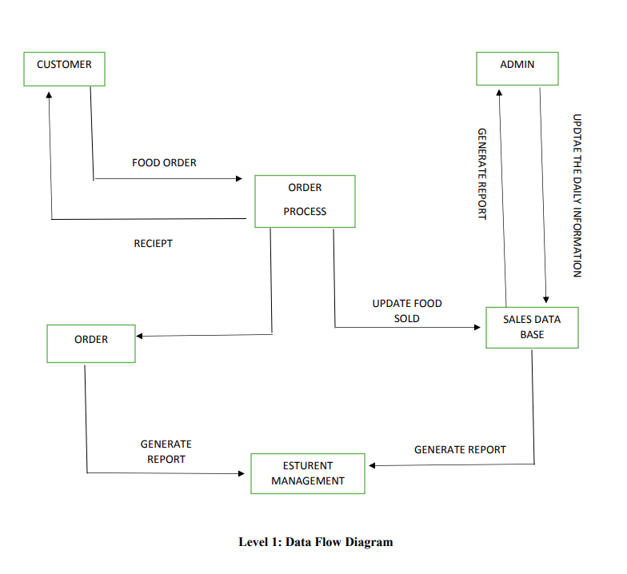

:Data flow diagram-2

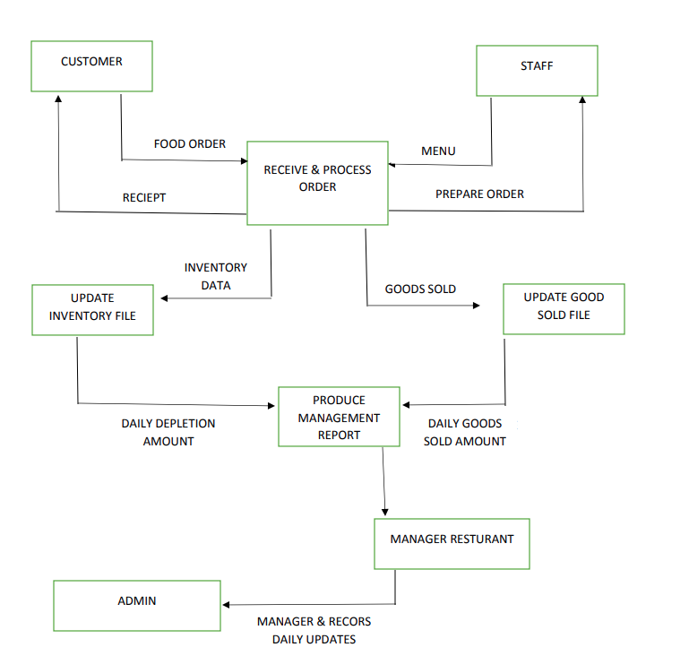

:Data flow diagram-3

REQUIREMENT SPECIFICATION

HARDWARE REQUIREMENTS -

* MEMORY (RAM): 1.00 GB .
* SYSTEM TYPE: 64-bit OS, x64-based processor .
* STORAGE CAPACITY: 30 GB HDD .
* CPU: 2.30GHz.

SOFTWARE REQUIREMENTS-

* OPERATING SYSTEM: Windows 7 or Higher .
* Development Tools: visual stdio code, xampp control panel,Html,PHP.
* System design tools.

CHAPTER 3

SYSTEM DESIGN

CHAPTER 4

SYSTEM IMPLEMENTATION

MODULE DESCRIPTION-

Every Project, module and task has the details like task, /Module/ name/start date/ end date, respective modules and member details etc all are stored in a central repository which can be accessed by the employees/restaurant staf based upon their rights. This application is comprised of the following modules.

* Admin Module.
* Manager Module.
* Senior Manager Module.
* Resturent owner Module.
* Software Engineers Module.
* Customar Module.
* Management System.

PROJECT SCREEN SHOTS

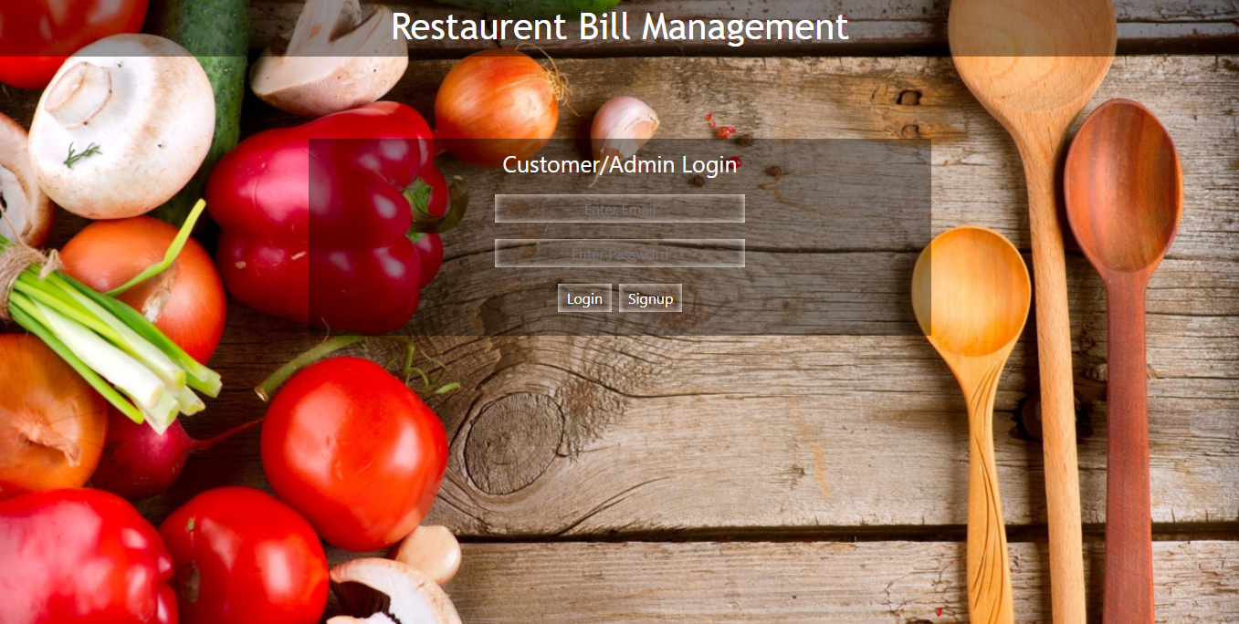

: Login page

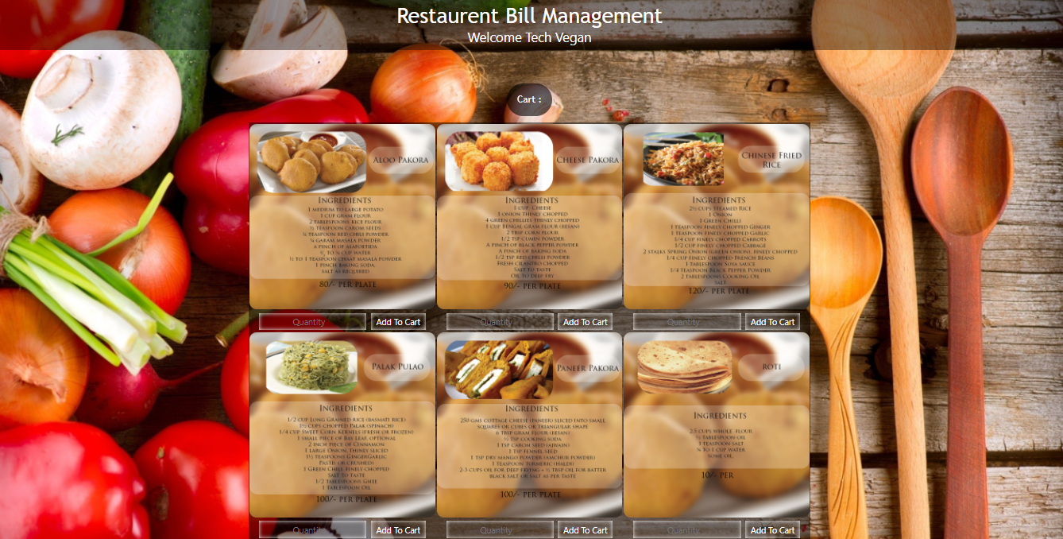

: Manu Area

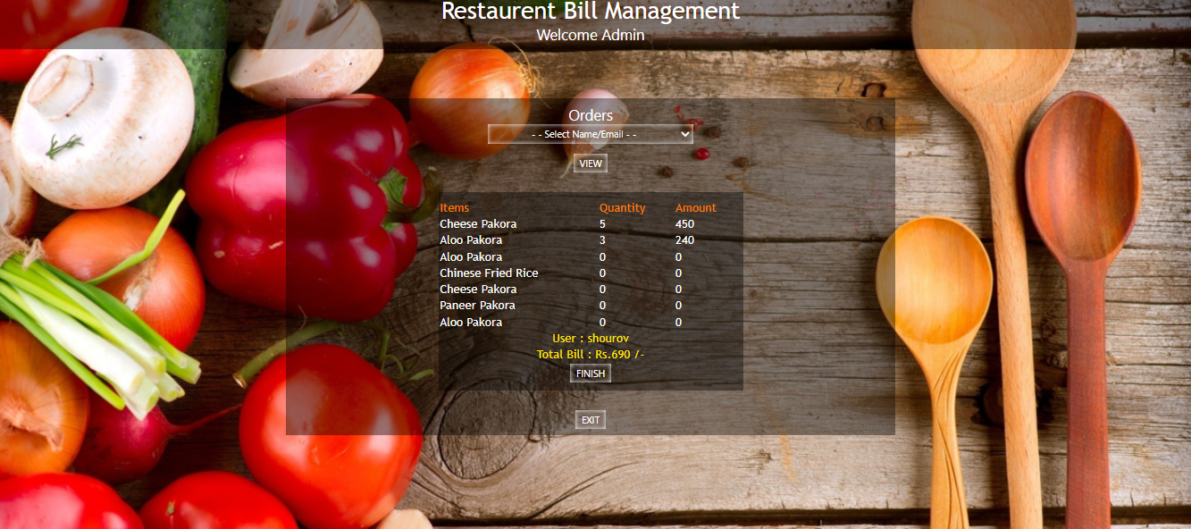

**: Checkout and payment**

CHAPTER 5

SYSTEM TESTING

**What is Testing?**

In computer hardware and software development, testing is used at key checkpoints in the overall process to determine whether objectives are being met. For example, in software development, product objectives are sometimes tested by product user representatives. Software testing is very important because of the following reasons: Software testing is really required to point out the defects and errors that were made during the development phases. It's essential since it makes sure of the customer reliability and their satisfaction in the application.

**Types of Testing:**

• Unit Testing.

• Integrated Testing.

\***Unit Testing:**

Unit testing is the testing of an individual unit or group of related units. It is often by the programmer to test that the unit he/she has implemented, is producing output against given input.

**\* Integrated Testing:**

Integration testing is testing in which a group of components are combined to produce output. Also, the interaction between software and hardware is tested in integration testing if software and hardware components have any relation.

**Test Plan:**

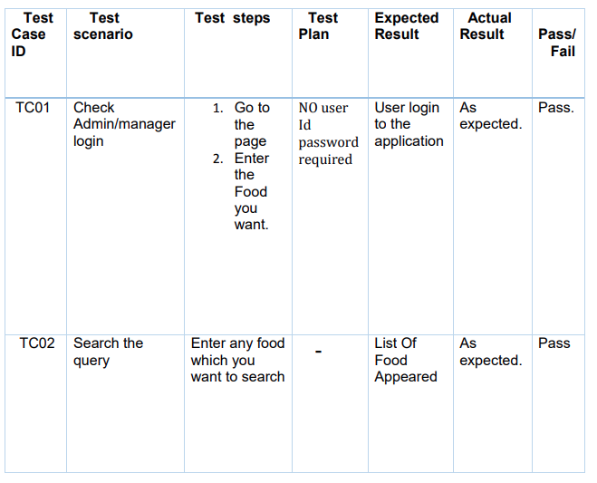

**Test Plan:**

|  |  |  |  |  |
| --- | --- | --- | --- | --- |
| Serial number | Work breakdown  structure | Project team member | result | Proposed  Date of completion |
| 1 | Coding,analysis | Shourov roy | completed | - |
| 2 | Design,plan | Somu saha | completed | - |
| 3 | Testing,implement | Lam ya auntipa | completed | - |
| 4 | ALL WORK | TEAM MEMBER | UPDATING | - |

CHAPTER 6

FUTURE SCOPE

1. Enhanced and Rich UI will be Designed.

2. Special Offer will be implemented.

3. Another payment option will be included.

4. User Will get a Discount of 30% in an order of Rs 300 or above.

CONCLUSION

We were able to create a computerized system for Silk Route to maintain billing & Restaurant records .This system is able to store billing records securely and retrieve the records whenever needed easily.Data entering of customers and employees are also included in this system along with the order and the billing process.Customers,restaurant records and employees are interconnected in order to maintain the accuracy of this system .This system can also be further improved adding many other features and including the other systems as well. Finally we believe that we were able to launch an effective computerized system to the restaurant causing the restaurant to perform well in the future regarding the billing and restaurant records.

CHAPTER 7

REFERENCES

Besides these we were referring the online manuals from the sites.

* <https://docs.php.earth/faq/misc/structure/>
* [Top 10 Backend Project Ideas For Beginners Portfolio In 2022 (devdevshow.com)](https://devdevshow.com/backend-project-ideas-for-beginners-portfolio/)
* [Full Stack Development Projects Ideas and Tips (crampete.com)](https://www.crampete.com/blogs/full-stack-development-projects/)
* [GitHub: Where the world builds software · GitHub](https://github.com/)